MN-08
2016 IE Strategy Memorandum

Updated on 4/25/16
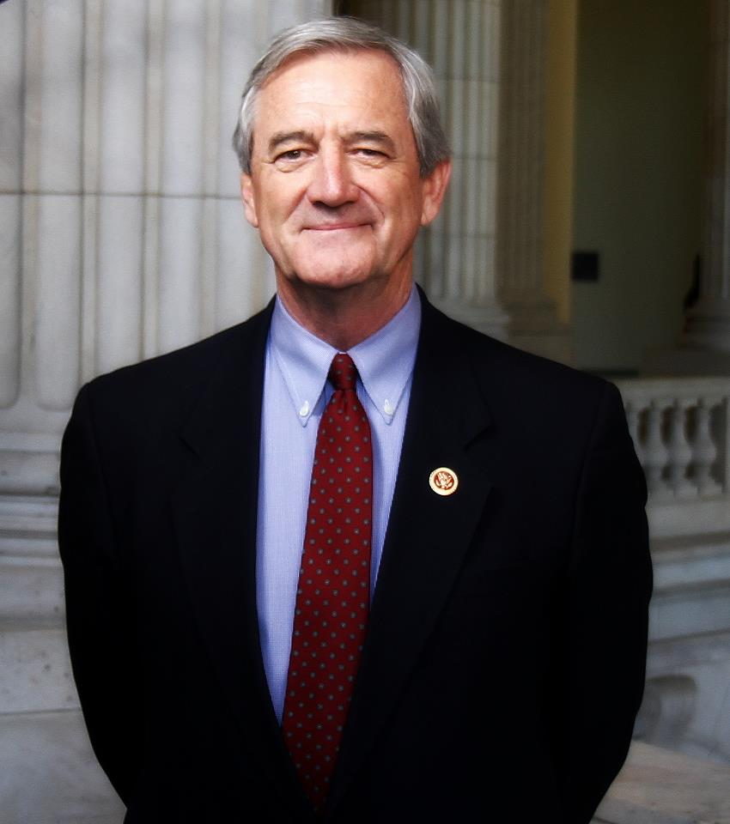


RICK NOLAN STEWART MILLS
CoH: $701,123.50 CoH: $232,069.36
Date: 4/15/16 Date: 4/15/16
Occupation: Congressman Occupation: Former owner of Fleet Farms

SECTION I: Race Overview
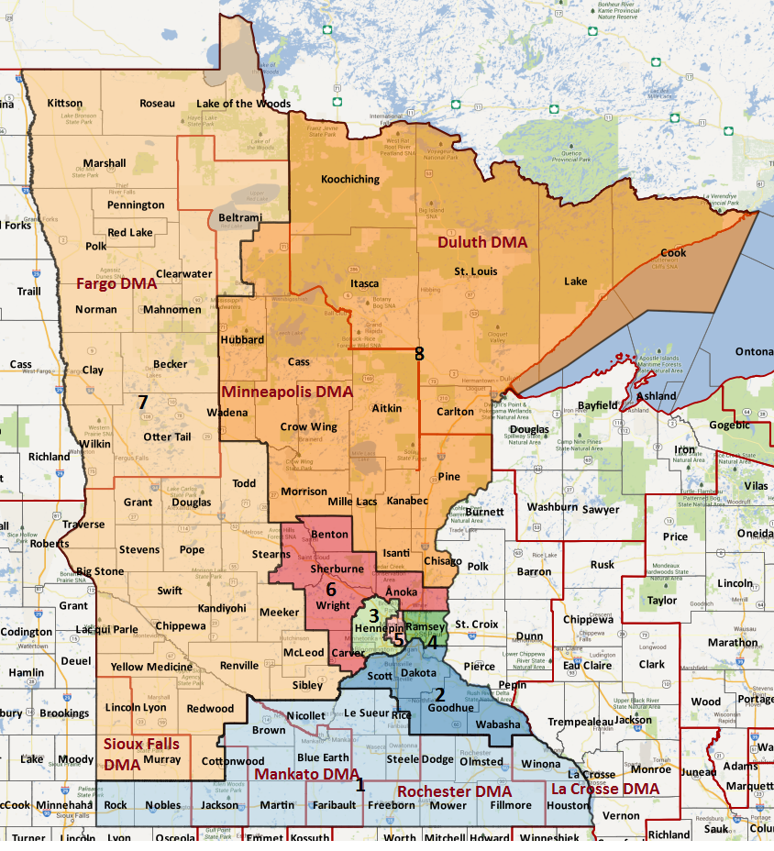

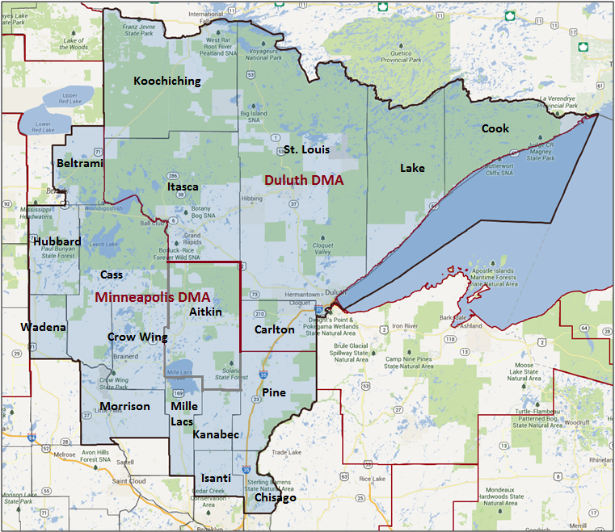

Media Market Costs

TV DMA | % of  CD | I.E.  35+ CPP | Cable CPP
MINNEAPOLIS | 53% | $400 | $235
DULUTH | 47% | $65 | $130
NH-02 TOTALS: | 100.0%
Radio Landscape
DMA | Universe | CPP
Minneapolis | 233,600 | $305
Duluth | 135,500 | $40

Digital Landscape
  - Persuasion universe size: 64,574
  - Audience extension (key demos): Independents & Democrats
  - Weekly budget for full coverage: $17,499.62
  - Reach
    - YouTube - 320,378
    - Pandora - 149,781

Presidential Statistics
Cycle | Candidate | Party | Vote
2012 | Obama | DEM | 52.8%
2012 | Romney | REP | 47.2%
2008 | Obama | DEM | 54.3%
2008 | McCain | REP | 45.7%%

Congressional Statistics
Cycle | W/L | Candidate | Party | Vote
2014 | W | NOLAN | DEM | 50.73%
2014 | L | MILLS | REP | 49.27%
2012 | W | NOLAN | DEM | 54.50%
2012 | L | CRAVAAK | REP | 45.50%

NCEC Data
Dem Performance: 54.8%
BVAP: 1%
Hispanic: 1.6%
Asian: .6%
Total Minority: 3.2%%
Critical Dates
Filing Date: May 31st 2016
Primary Date: August 9th 2016

Summary of 2014 Cycle Spending by Outside Groups

TV Competitive Summary – Minneapolis
Campaign/Group | Total GRPs | Total Dollars
Rick Nolan/DCCC | 70 | $22,000
Mills/NRCC | 566 | $64,449
NRCC | 6045 | $2,881,345
DCCC | 8,050 | $3,925,151
House Majority PAC | 3,582 | $1,273,033
AFSME People | 830 | $308,200
National Rifle Association | 1292 | $742,950
American Action Network | 1926 | $752,071
Chamber of Commerce | 1745 | $626,862
Good Guys vs Bad Guys | Total GRPs | Total Dollars
Good Guys | 14,562 | $5,528,384
Bad Guys | 11,574 | $5,067,677

TV Competitive Summary – Duluth

Campaign/Group | Total GRPs | Total Dollars
Rick Nolan/DCCC | 1,012 | $53,314
Mills/NRCC | 749 | $29,952
NRCC | 2,340 | $256,015
DCCC | 5,232 | $535,830
House Majority PAC | 4,876 | $369,392
National Rifle Association | 2,046 | $163,670
Americans for Prosperity | 1,358 | $69,673
U.S. Chamber of Commerce | 2,050 | $151,884
American Action Network | 320 | $39,704
Good Guys vs Bad Guys | Total GRPs | Total Dollars
Good Guys | 11,120 | $958,536
Bad Guys | 8,863 | $710,898

Summary of Digital Program:

The 2014 DCCC IE Program was up with a buy of $170,655 for a total of 7 weeks in the Minneapolis-St. Paul (weeks 7-3 and 1) and Duluth Media Markets (3-1).

Persuasion Program

The DCCC IE ran a total of 31 unique pieces of digital in the Minneapolis market. The ads consisted of pre-roll video, Facebook, Twitter, search and banner ads. Our messaging online always matched what we were on the air with. Weeks 3-1 in Duluth we reused creative with the original ad it was paired with in Minneapolis.

Due to the consistent theme of Mills not supporting the middle class and tax fairness, we did not always do a full slate change every time we changed traffic. We would do mini-swaps of only Facebook, Twitter, the ad and Pandora.

Summary of 2012 Cycle Spending by Outside Groups

TV COMPETITIVE SUMMARY - MINNEAPOLIS
Campaign/Group | GRPs
Nolan/DCCC | 145 | $38,810
Cravaack/NRCC | 187 | $60,375
AFSCME | 1,185 | $383,974
DCCC | 6,000 | $2,025,915
NRCC | 3,445 | $1,099,795
House Majority PAC | 2,082 | $694,581
HMP/SEIU | 803 | $234,375
Lunch Pail Republicans | 25 | $8,269
American Action Network | 3,107 | $1,133,350
Good guys v Bad guys | Total
Good Guys | 9,030 | $3,377,655
Bad Guys | 6,764 | $2,301,789
TV COMPETITIVE SUMMARY - DULUTH
Campaign/Group | GRPS | Total Dollars
Nolan/DCCC | 729 | $38,615
AFSCME | 875 | $83,875
Minnesota DFL | 2,364 | $222,352
House Majority PAC | 3,194 | $379,400
Regular Folks on the Range | 242 | $13,065
Lunch Pail Republicans | 44 | $8,347
American Action Network | 2,926 | $259,320
Good guys v Bad guys | Total
Good Guys | 6,675 | $737,307
Bad Guys | 3,699 | $267,667

Pre-Election Day Voting

Type of  “Early Voting” | Start Date  End Date | Percent of  Vote Cast Using this Method | Brief Description  (where/how  do people vote) | Timeframe (when does the majority of voting happen)
Early Vote/In Person Absentee | Sept 23rd – Nov 8th |  | Elections offices or any other location designated by county auditor
Vote By Mail | Sept 23rd – Nov 8th |  | Ballots must be returned by election day

SECTION II: DISTRICT OVERVIEW

- District Overview and Data

  - Political Landscape
- Incumbent Democratic Congressman Rick Nolan and Republican Stuart Mills will face each other once again in the 2016 election. The two previously competed in the district in 2014. Nolan’s support comes primarily from the northeast counties of St. Louis and Carlton. Mill’s base is located in the south and eastern portion of the district in Cass, Crow Wing, Hubbard, Morrison, and Isanti counties.
- In an October 2015 DCCC poll, Nolan led Mills by 11 points (40% to 29%, with 31% undecided).
- In a March 2016 poll conducted by Victoria Research on behalf of the Nolan campaign, Nolan led Mills by 5 points (48% to 43%, with 9% undecided).
- In 2014, Green Party candidate, Ray “Skip” Sandman appeared on the ballot and received 4.3% of the vote (larger than the major party margin of victory). Sandman voters were environmentally concerned and dissatisfied with Nolan’s record on the environment. His presence on the ballot siphoned votes from Nolan. There is currently no indication that any third party candidate will be on the ballot. In 2012, there was no third party candidate on the ballot.

  - District Demographics
- MN-08 stretches from the outer suburbs of the Twin Cities north to Canada and Duluth. It contains a diverse population of voters including urban voters in Duluth, upper-middle class voters in the Twin Cities and working class voters in the Minnesota Iron Range.
- The district is split nearly evenly between the Minneapolis-St. Paul ($284 CPP, 51.9% of expected vote) and Duluth-Superior ($45 CPP, 48.3% of expected vote) media markets.
- The district is heavily White and has a high concentration of youth voters in St. Louis due to the presence of several universities.
- Cook Partisan Voting Index: D+1
- Urban Population: 3.4%
- Rural Population: 80.6%
- Suburb Population: 16%
- Median Income: $51,322
- Poverty Status: 8.2%
- Military Veterans: 13%
- Race/Ethnic Origin: 97.5% White; 1% Black; .6% Asian; .9% Hispanic

  - Electoral Context
- In 2012, President Obama won this district with 52.8% of the vote compared to 54.4% in 2008 – a 1.6 point drop in support over four years. He won most of the precincts in the northeastern part of the district around the Duluth area, as well as six of the eighteen counties, including Carlton (63.4%), Cook (62.0%), Itasca (55.0%), Koochiching (54.8%), Lake (60.8%), and St. Louis (65.2%).
- That year, Nolan received 54.5% of the vote, beating his opponent Chip Cravaack by a margin of 8.9 points (31,456 votes). He received 5,215 more votes than President Obama, (+1.7 points vs. Obama). Like President Obama, Congressman Nolan also won most of the precincts in the northeastern part of the district, though he additionally performed well in the central part of the district. For example, Congressman Nolan won two counties in the center of the district that President Obama didn’t win, Aitkin (53.1% support, +3.8 points vs. Obama) and Pine (52.7% support, +3.0 points vs. Obama). The Congressman carried eight of the eighteen counties, including Aitkin (53.1%), Carlton (62.9%), Cook (61.0%), Itasca (56.6%), Koochiching (58.8%), Lake (60.1%), Pint (52.7%), and St. Louis (63.2%). Congressman Nolan outperformed President Obama in almost every county in the district, except for Carlton (62.9% support, -0.4 points vs. Obama), Cook (61.0% support, -1.0 points vs. Obama), Lake (60.1% support, -0.7 points vs. Obama), and St. Louis (63.2% support, -2.0 points vs. Obama). Nolan spent $1.2 million compared his Republican opponent, Chip Cravaack’s $2.3 million spent. Nolan underperformed 2012 DPI by 2 points.
- In 2014, Rep. Nolan narrowly won reelection with 50.7% of the two-way vote. Al Franken, the Democratic candidate for Senate, performed 5.3 points better than Nolan in the district. Nolan lost a significant portion of the Democratic vote in Carlton and St. Louis counties. Nolan’s two-way support in the Carlton fell 7.0 points between 2012 and 2014. Nolan received 9.0 less than Franken in the county. Nolan’s two-way support in St. Louis County was down 3.6 points from 2012, and he received 7.1 fewer points than Sen. Franken in the county. Nolan’s victory was driven by his better than expected performance in the more conservative counties in the Minneapolis-St. Paul media market. While his support fell in the Duluth-Superior market 4.1 points from 2012 to 2014 (61.9% to 57.9%), it only fell 3.3 points (47.4% to 44.1%) in the Minneapolis-St. Paul. The Nolan campaign’s spending was competitive during the cycle, spending $2,113,281 compared to Mills’ $2,130,682 spent. Nolan underperformed 2014 DPI by 4.4 points.
- For 2016, using the previous Presidential election as a guide, official Secretary of State records from 2012 show a turnout rate of 80.3% of registrants including Election Day registrants (362,646 total votes cast).
- Applying that turnout rate forward to the 2016 current registered voters, we can expect to see 80.3% of registrants turn out, casting 357,029 total votes, again, relying on the latest registration statistics from the Secretary of State.
- To reach a goal of 52% support overall, a successful campaign would need at least 185,470 raw votes. A one-point shift in support equates to 3,570 raw votes.
- The most notable change in the 2016 electorate from 2014 will be the increase in turnout and youth voters. Youth drop off during the 2014 midterm election was -3.4%.
- Historically, there is positive roll-off in this district. The Democratic congressional candidate typically receives more votes than the presidential candidate. In 2012, Rep. Nolan received 5,215 more votes (2.8%) than President Obama.
- The district’s current DPI of 54.8% is down from 55.1% in 2014 and 56.4%, in 2012, as a result of the district’s rural areas trending away from Democrats in recent years.
- The presidential contest will be the only race higher than the congressional race on the ballot in Minnesota this year. This is the first time this has happened since 2004. That year, Rep. Jim Oberstar, the Democratic candidate, received 19.5% more raw votes than Democratic presidential nominee, Senator John Kerry. As Minnesota will not be at the top of the presidential campaign’s list of priority states, enthusiasm around Nolan will be critical to motivating supportive voters.
- A ballot question approving the creation of an independent board of citizens to decide legislative pay is already on the ballot. Currently in consideration for ballot question (meaning they must first be approved by a majority of the legislature) are two civil rights measures: gender equality and electronic data protection.
- No-excuse absentee voting continues for the second major cycle, as well as mail-only precincts (about 1,500 total, mostly rural areas) where there are no polling places at all.
  - Press Presence
- The district is split nearly evenly between the Minneapolis-St. Paul ($284 CPP, 51.9% of expected vote) and Duluth-Superior ($45 CPP, 48.3% of expected vote) media markets.
- There is a combination of local radio, local papers and Duluth TV stations that cover the district (though half the district gets news from the Twin Cities on TV).

Media outlets include:
- Duluth News Tribune
- The Bemidji Pioneer
- Brainerd Daily Dispatch
- The Ely Echo
- Minneapolis Star Tribune
- Minnesota Post
- The Grand Rapids Herald Review

SECTION III: MESSAGE

Message Box

Democrat Self Frame  Instead of giving tax breaks to companies that ship jobs overseas and nation building we need to invest in the middle class here in America. That means protecting social security & Medicare, raising the minimum wage, and balancing the budget the right way not on the backs of the middle class. | Republican Self Frame  For nearly three decades Stewart worked at his family’s businesses, Mills Fleet Farm and Mills Automotive Group, where he learned the meaning of hard work and what it takes to grow jobs and successfully maintain a main-street business. Mills Fleet Farm is embedded in communities throughout the Midwest, helping give Stewart insight into what makes these communities tick and the struggles families face every day. He also learned how to be a problem solver, working with diverse voices within the company and community members. Unlike so many in Washington, D.C., Stewart is not a lawyer or a lifelong professional politician. He’s a businessman with a lifetime of experiences helping run a large company with thousands of employees.
Likeliest Attacks on Democrat  Nolan was one of only 4 votes in Congress against funding Veterans’ Affairs, which would deprive our veterans of the health care and other services they need, including benefits that reach out to rural veterans. He also voted to cut pension payments for veterans.  Nolan is a failed businessman who had to file for bankruptcy when his Middle Eastern exporting businesses could not pay its debts.  Rick Nolan voted to raise his own pay in Congress 4 times in 5 years, and skipped 37% of the votes that took place during one year in Congress. | Best Attacks on Republican  Stewart Mills III is a silver-spoon fed “inherited” multi-millionaire who is out of touch with the real needs of the people in the 8th District. He has never held a job in his life because he inherited his family’s business, and most recently sold it for $1.2 billion, and so he doesn’t know what it’s like to have to make ends meet. This is evidenced by the fact he doesn’t believe rich people should pay their fair share of taxes, his belief that “all options are on the table” when it comes to social security, and his refusal to take a position on TPP.

- Rick Nolan

- Short Biography
Rick is a father and grandfather, married to Mary Nolan for 30 years, and born and raised on the Cuyuna Iron Range in Minnesota’s 8th District. He is a small-business owner who created jobs throughout northern Minnesota from the sawmill and pallet factory he owned in Emily.

Rick was first elected to congress from 1975 to 1981. In 2011 he was nominated to run against Rep. Cravaack. He won and assumed office in 2012.

- Self-Frame
Instead of giving tax breaks to companies that ship jobs overseas and nation building we need to invest in the middle class here in America. That means protecting social security & Medicare, raising the minimum wage, and balancing the budget the right way not on the backs of the middle class.

- Likely Attacks
- Nolan was one of only 4 votes in Congress against funding Veterans’ Affairs, which would deprive our veterans of the health care and other services they need, including benefits that reach out to rural veterans. He also voted to cut pension payments for veterans.
- When Nolan was president of the Minnesota World Trade Center, the center cost taxpayers at least $5‐point‐5 million dollars and was described by the Star Tribune as “expensive, overly political, and unnecessary.”
- Nolan is a failed businessman who had to file for bankruptcy when his Middle Eastern exporting businesses could not pay its debts.
- Rick Nolan voted to raise his own pay in Congress 4 times in 5 years, and skipped 37% of the votes that took place during one year in Congress.
- Nolan recently described Fidel Castro as “a remarkable man … exceptionally bright, unbelievably well-informed, and very charismatic, and on a personal level, very engaging.”

- Assessment of Democratic Fundraising
DEMOCRAT  Rick Nolan | Q1 2015 | Q2 2015 | Q3 2015 | Q4 2015 | Q1 2016
Goal | n/a | 300,000 | 300,000 | 305,000 | 325,000
Actual Raised | 276,758 | 164,480 | 259,849 | 187,474 | 230,395

- Strengths and Weaknesses of Campaign

- Rick Nolan looks and sounds like the district. He is able to invoke a message of economic populism that does well there.
- However, Nolan also can at times be his own worst enemy. Nolan has the ability to be a strong fundraiser but often produces anemic results that put his campaign in peril.
- Nolan also can at times want to turn back the clock 3 decades on campaign tactics. Last cycle he insisted his team pull down an effective ad hitting Mills and forced the team to air an ad touting his accomplishments as an effective Congressman. When the team polled they found they had slipped in the polls and went back to the previous ad that was working.

- Stewart Mills

- Short Biography
For six generations Stewart Mills’ family has lived and worked in Minnesota’s 8th District. For nearly three decades Stewart worked at his family’s businesses, Mills Fleet Farm and Mills Automotive Group. Starting with one store in 1955, the Mills family developed Mills Fleet Farm into a multi-state operation, with 35 stores throughout Minnesota, Wisconsin, North Dakota, and Iowa.
He resides in the Brainerd Lakes area with his wife, Heather, the daughter of a Norwegian immigrant, and his five children. After transitioning out of his business career, Stewart Mills is throwing his full energy into representing Minnesota in congress.

- Self-Frame
For nearly three decades Stewart worked at his family’s businesses, Mills Fleet Farm and Mills Automotive Group, where he learned the meaning of hard work and what it takes to grow jobs and successfully maintain a main-street business.
Mills Fleet Farm is embedded in communities throughout the Midwest, helping give Stewart insight into what makes these communities tick and the struggles families face every day. He also learned how to be a problem solver, working with diverse voices within the company and community members.
Unlike so many in Washington, D.C., Stewart is not a lawyer or a lifelong professional politician. He’s a businessman with a lifetime of experiences helping run a large company with thousands of employees.

- Best Attacks

Republican Candidate | Ryan Budget(s) – (Include if its Votes or Statement) | Privatize Social Security | Defund Planned Parenthood | Anti-Choice Position
Stewart Mills |  | X | X | X

MN-08 Research

Stewart Mills (Republican Challenger) Vulnerabilities

Stewart Mills is a wealthy businessman who challenged Rep. Rick Nolan in 2014, losing by 1.4%. His family owns Mills Fleet Farm, a well-known chain of outdoors and sporting goods stores with 36 locations in Minnesota and nearby states. He has worked for Mills Fleet Farm since graduating from college. Mills’ net worth is estimated between $34 and $115 million, and he stands to profit more from the recent sale of Mills Fleet Farm to private equity firm, KKR. Full details of the sale remain undisclosed, but the sale was valued at an estimated $1.2 billion. Mills lacks substance and supports positions that would hurt the middle class, seniors, women, and workers.

Top Hits 2016

- Called Trump’s rhetoric “overly bombastic and overly hyperbolic”—said his call to ban Muslims was distracting from the real issues of the day
- Said he wanted a “flatter” and “fairer” tax code
- He finally took a position on the TPP—first said it was a “non-issue” and that he would not speak about it but finally said he opposed it and would vote against it
- 2016: Mills Fleet Farm was fined $40,000 for selling gas at illegally low prices
- Despite MFF receiving $900k subsidy to build new store, city contract did not contain union provision, allowing Mills to pay workers below prevailing wage
- KKR purchased Mills Fleet Farms for an estimated $1.2 billion—he and his family stand to profit heavily
  - KKR is a large private equity firm known for purchasing companies and laying off tens of thousands of employees—e.g., Safeway and RJR Nabisco; specialized in “leveraged buyouts
  - 2015: KKR Paid $30 million to SEC to settle “broken deal” charges
  - Purchase of RJR Nabisco became basis for a book and 1993 HBO movie, “Barbarians At The Gate,” which chronicled Wall Street excess and greed
- USW member, Steve Biondich, who was featured in ad for Mills posted racist and sexist memes on his own personal Facebook page
- Said he was pro-life and was “very, very strongly against federal funding … going to any abortion provider”
- Said Planned Parenthood was using “a shell game” and that if they were actually “serious about providing women's services, they should, in an instant, stop providing abortions”; said they should be defunded
- 2014 Facebook Post: Supported local crisis pregnancy center and touted help “provid[ing] resources” at fundraiser
- Said repealing the ACA is a central focus of his campaign, but admitted that he likes the “good things” it has done
- Still has not learned how to conduct himself on social media—has posted photos of himself shirtless, doing pull ups, and shooting guns

Top Hits 2014

- Rich guy who inherited his wealth doesn’t want to pay his fair share of taxes, wants to help the wealthy to the detriment of the middle class
- Doesn’t want to pay his fair share of taxes, supports a flat tax that benefits the wealthy—said he was “personally offended” at the notion that the rich don’t pay their fair share
- MFF has benefited from public subsidies in multiple states
- Took money from the Koch brothers who shut down a Georgia-Pacific plant in Duluth
- Bizarre, inappropriate posts on social media
- Did not want to raise the minimum wage—said minimum wage jobs were “stepping stone[s]” for teenagers
- Polling last cycle showed that Mills Fleet Farm was a beloved brand in the district so no attacks were directed at the company
- Said all options on table for Social Security reform
- Opposed the Ryan budget because it did not sufficiently address health care issues

Rick Nolan (Democratic Incumbent) Vulnerabilities

- Voted against defense bill in 2013 because he thought it did not have sufficient funding for veterans but that vote has been portrayed as a vote against the troops
- Mills said Nolan had voted to “support terrorist groups” because he supported the Iranian nuclear deal but later denied this statement
- Mills criticized him on previous visit to Cuba in the 1970’s and complementing Fidel Castro
- Was cast as a Washington insider who is too liberal for the district and out of touch
- Mills criticized Nolan for supporting the reauthorization of the Export-Import Bank because the Bank gave a loan to an Australian mining company that could potentially hurt Minnesota iron ore companies
- Cast doubt on whether Nolan had even read the TPP deal

SECTION V: Appendix

- 2016 Campaign Side Consulting Team
Media: Rallston Lapp
Mail: Bergman Zwerdling
Polling: Donna Victoria
Online/Digital: New Blue
Self-Research:

- Summary of Past Races and Important Differences for 2016
In 2014, Rep. Nolan narrowly won reelection with 50.7% of the two-way vote. Al Franken, the Democratic candidate for Senate, performed 5.3 points better than Nolan in the district. Nolan lost a significant portion of the Democratic vote in Carlton and St. Louis counties. Nolan’s two-way support in the Carlton fell 7.0 points between 2012 and 2014. Nolan received 9.0 less than Franken in the county. Nolan’s two-way support in St. Louis County was down 3.6 points from 2012, and he received 7.1 fewer points than Sen. Franken in the county. Nolan’s victory was driven by his better than expected performance in the more conservative counties in the Minneapolis-St. Paul media market. While his support fell in the Duluth-Superior market 4.1 points from 2012 to 2014 (61.9% to 57.9%), it only fell 3.3 points (47.4% to 44.1%) in the Minneapolis-St. Paul. The Nolan campaign’s spending was competitive during the cycle, spending $2,113,281 compared to Mills’ $2,130,682 spent. Nolan underperformed 2014 DPI by 4.4 points.
Role of the I.E.
Despite the shifting demographics of the district, a barrage of outside spending to support a candidate touted by the NRCC as a rising star and “Brad Pitt of the Republican Party,” and a difficult national environment that made attacking Nolan’s votes on veterans and key issues easy, Nolan was able to win. Even concerns about fundraising didn’t play out as expected; Nolan outraised Mills in Q3. Although Mills beat Nolan on air, Mills was forced to use some of that airtime to address both HMP’s and the IE’s ads in responses. “Good Guys” were able to carry the Minneapolis market, while Republicans out pointed us in the more Democratic-leaning Duluth market (that said, we spent enough to keep from losing the necessary support in the market). It was clear from our track Week 6 that Nolan was in a good position to win this race, in spite of the attacks from the NRCC and others, and in spite of his liberal record during a particularly tough year for Democrats. Mills’ name ID was rising, but so were his negatives.

One key factor to the success here was maintaining a clear and coherent message that was consistent and pounded away at the same theme for weeks (with complementary messaging from other Democratic actors and compelling creative elements), while the Republicans failed to create a coherent and consistent message against Nolan.

The national press complimented the strength of the IE’s program here in the race: The Washington Post wrote an article citing our ads as “ how to run a campaign against a rich guy”, while Roll Call cited the DCCC’s work as one of the best campaigns of the cycle the reason for Nolan’s re-election.

Media Summary: The 2014 DCCC IE Program aired 6 television spots in the Minneapolis-St. Paul Media Market with a total of 7,650 GRPs and re-ran 4 television spots in the Duluth Media Market with a total of 5,225 GRPs. All 8 spots followed a tax fairness theme. Three Point did a shoot from 8/25 to 8/26, from which we created 3 original ads.

Ads run by DCCC in MN-08

- Spot 1 – D3C14-MN-T01 “Costs” // Minneapolis-St.Paul (1327 GRPs): Ad utilized tracking footage of Mills playing with his hair.
- Spot 2 – D3C14-MN-T02 “Big One” // Minneapolis-St.Paul (1571 GRPs): Shot in Minnesota using paid actor.
- Spot 3 – D3C14-MN-T03 “ Another Big One” // Minneapolis-St.Paul (1219 GRPs)/ Duluth (925 GRPs): Footage shot in Minnesota.
- Spot 4 – D3C14-MN-T04 “ Fish” // Duluth (1408 GRPs): This is the same ad as “Big One” with an updated citation due to a problem with WCCO.
- Spot 5 – D3C14-MN-T05 “ Lifestyle” // Minneapolis-St. Paul (1192 GRPs): Ad uses tracking footage of Mills playing with his hair and outside the Capitol Hill Club.
- Spot 6 – D3C14-MN-T06 “Look” // Duluth (1580GRPs): This is the same ad as “Costs” with an updated citation due to a problem with WCCO.
- Spot 7 – D3C14-MN-T07 “ Coverage” // Minneapolis-St. Paul (1192 GRPs): Ad features debate tracking footage with two shadowed.
- Spot 8 – D3C14-MN-T08 “ Handed” // Minneapolis-St. Paul (1150 GRPs)/ Duluth (1313 GRPs): This ad is a mixture of stock footage, tracker footage from previous ads with footage from some of Stewart Mill’s ads.

- 2016 Targets
  - Using the previous Presidential election as a guide, official Secretary of State records from 2012 show a turnout rate of 80.3% of registrants including Election Day registrants (362,646 total votes cast).
  - Applying that turnout rate forward to the 2016 current registered voters, we can expect to see 80.3% of registrants turn out, casting 357,029 total votes, again, relying on the latest registration statistics from the Secretary of State.
  - To reach a goal of 52% support overall, a successful campaign would need at least 185,470 raw votes. A one-point shift in support equates to 3,570 raw votes.
  - The most notable change in the 2016 electorate from 2014 will be the increase in turnout and youth voters. Youth drop off during the 2014 midterm election was -3.4%.
  - Historically, there is positive roll-off in this district. The Democratic congressional candidate typically receives more votes than the presidential candidate. In 2012, Rep. Nolan received 5,215 more votes (2.8%) than President Obama.

DEMOCRATS START THIS RACE NARROWLY AHEAD BY ROUGHLY 2,166 VOTES (52.7% STWO-WAY SUPPORT). VICTORY DEPENDS ON THE FOLLOWING:
- INCREASE SUPPORT IN SAINT LOUIS COUNTY TO 65.0%
- EARN AT LEAST 61.0% SUPPORT IN DULUTH-SUPERIOR MEDIA MARKET AND MAINTAIN SUPPORT IN MINNEAPOLIS-ST. PAUL MEDIA MARKET OF 44.1%
- MINIMIZE IMPACT OF LACK OF NOTABLE STATEWIDE RACES BY MAINTAINING ENTHUSIASM FOR CONGRESSMAN NOLAN
- EARN AT LEAST 56% SUPPORT AMONG VOTERS UNDER 30
- ACCOUNT FOR POTENTIAL THIRD PARTY CANDIDATE DEFECTING VOTES FROM CONGRESSMAN NOLAN

